.

 **Apache Tomcat**

 Apache Tomcat is an open-source implementation of the Java Servlet, JavaServer Pages, Java Expression Language, and Java WebSocket technologies. It is one of the most widely adopted application and web servers in the world today. Tomcat is simple to use and has a robust ecosystem of add-ons.

**Step 1: Install OpenJDK**

Tomcat requires Java to be installed. We’ll install OpenJDK , which is the default Java development and runtime in Ubuntu

The installation of Java is pretty simple

sudo apt-get update

sudo apt-get install default-jdk

**Step 2: Install Tomcat**

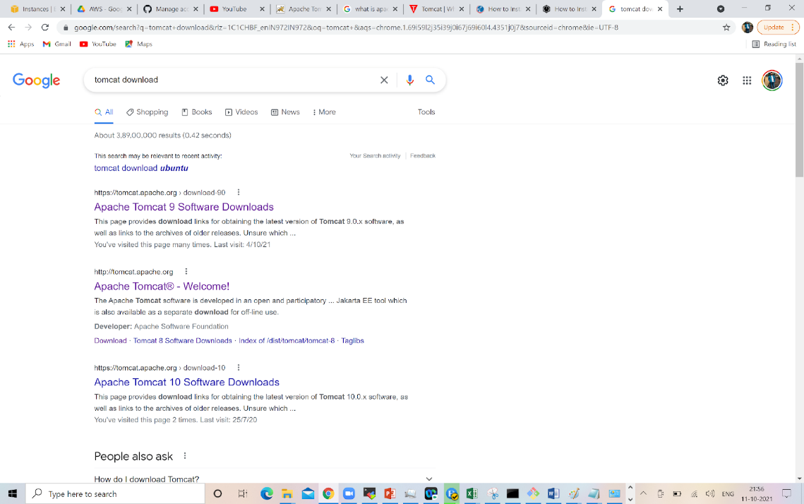

**:/opt$** https://mirrors.estointernet.in/apache/tomcat/tomcat-9/v9.0.54/bin/apache-tomcat-9.0.54.tar.gz

**output:**

/opt$ sudo wget https://dlcdn.apache.org/tomcat/tomcat-9/v9.0.54/bin/apache-tomcat-9.0.54.tar.gz

--2021-10-11 16:29:27--  https://dlcdn.apache.org/tomcat/tomcat-9/v9.0.54/bin/apache-tomcat-9.0.54.tar.gz

Resolving dlcdn.apache.org (dlcdn.apache.org)... 151.101.2.132, 2a04:4e42::644

Connecting to dlcdn.apache.org (dlcdn.apache.org)|151.101.2.132|:443... connected.

HTTP request sent, awaiting response... 200 OK

Length: 11576317 (11M) [application/x-gzip]

Saving to: ‘apache-tomcat-9.0.54.tar.gz’

apache-tomcat-9.0.54.tar.gz             100%[=============================================================================>]  11.04M  --.-KB/s    in 0.1s

2021-10-11 16:29:27 (103 MB/s) - ‘apache-tomcat-9.0.54.tar.gz’ saved [11576317/11576317]

**Step3: Untar the file by using below command**

**:/opt$** sudo tar -xvf apache-tomcat-9.0.54.tar.gz

**Step4: Rename the directory to apache-tomcat-9.0.54 to  tomcat9**

**:/opt$** sudo mv apache-tomcat-9.0.54 tomcat9

Step5: Enter in to tomcat folder

**:/**opt$ cd tomcat9/

Note: Switch to root user by using below command

step6:Start the tomcat bu using below commands

**:**/opt/tomcat9# cd bin/

**:**/opt/tomcat9/bin# sh startup.sh

**Output as below:**

:/opt/tomcat9/bin# sh startup.sh

Using CATALINA_BASE:   /opt/tomcat9

Using CATALINA_HOME:   /opt/tomcat9

Using CATALINA_TMPDIR: /opt/tomcat9/temp

Using JRE_HOME:        /usr

Using CLASSPATH:       /opt/tomcat9/bin/bootstrap.jar:/opt/tomcat9/bin/tomcat-juli.jar

Using CATALINA_OPTS:

Tomcat started.

Step8:Tomcat Port number is 8080

Acesses the tomcat application from web your public-IP:8080

**http://13.233.153.97:8080/**

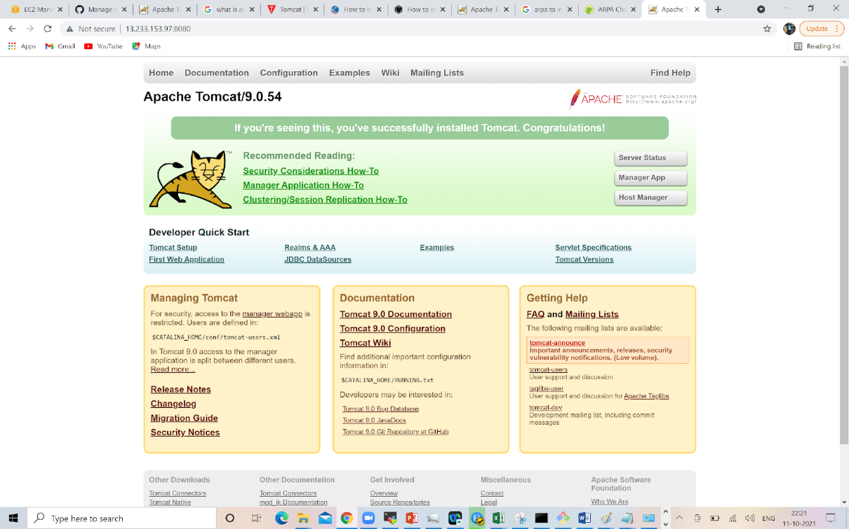

**Step9: Resolving 403 error** Click on manager app 🡪 we can see below output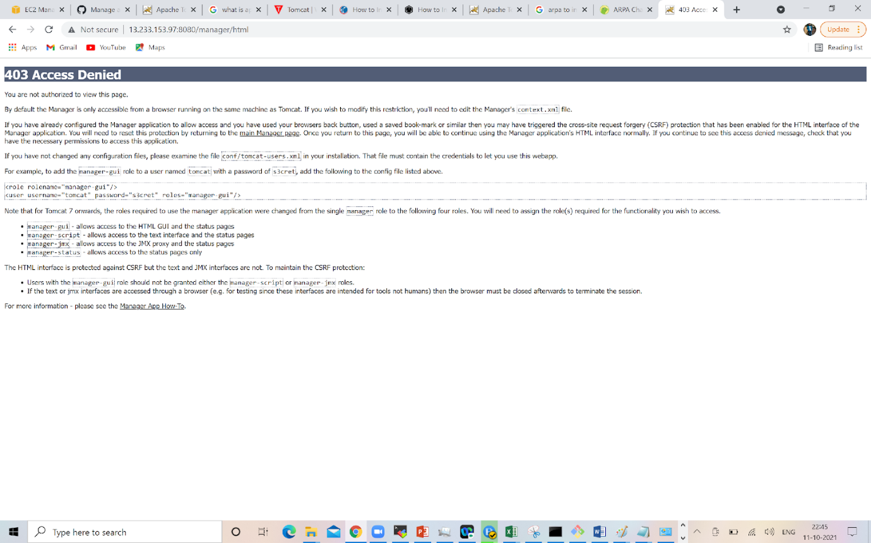

: sudo vi /opt/tomcat9/webapps/manager/META-INF/context.xml

**Open the file and make below changes**

**content look as below**

<Context antiResourceLocking="false" privileged="true" >

  <CookieProcessor className="org.apache.tomcat.util.http.Rfc6265CookieProcessor"

                   sameSiteCookies="strict" />

  <Valve className="org.apache.catalina.valves.RemoteAddrValve"

         allow="127\.\d+\.\d+\.\d+|::1|0:0:0:0:0:0:0:1" />

  <Manager sessionAttributeValueClassNameFilter="java\.lang\.(?:Boolean|Integer|Long|Number|String)|org\.apache\.catalina\.filters\.CsrfPreventionFilter\$LruCache(?:\$1)?|java\.util\.(?:Linked)?HashMap"/>

</Context>

**After modifications file should look as below one:**

<Context antiResourceLocking="false" privileged="true" >

  <CookieProcessor className="org.apache.tomcat.util.http.Rfc6265CookieProcessor"

                   sameSiteCookies="strict" />

  <Valve className="org.apache.catalina.valves.RemoteAddrValve"

         allow=".*" />

  <Manager sessionAttributeValueClassNameFilter="java\.lang\.(?:Boolean|Integer|Long|Number|String)|org\.apache\.catalina\.filters\.CsrfPreventionFilter\$LruCache(?:\$1)?|java\.util\.(?:Linked)?HashMap"/>

</Context>

**Step10: Now resolving 401 error**

Click on manager app 🡪 we can see below output

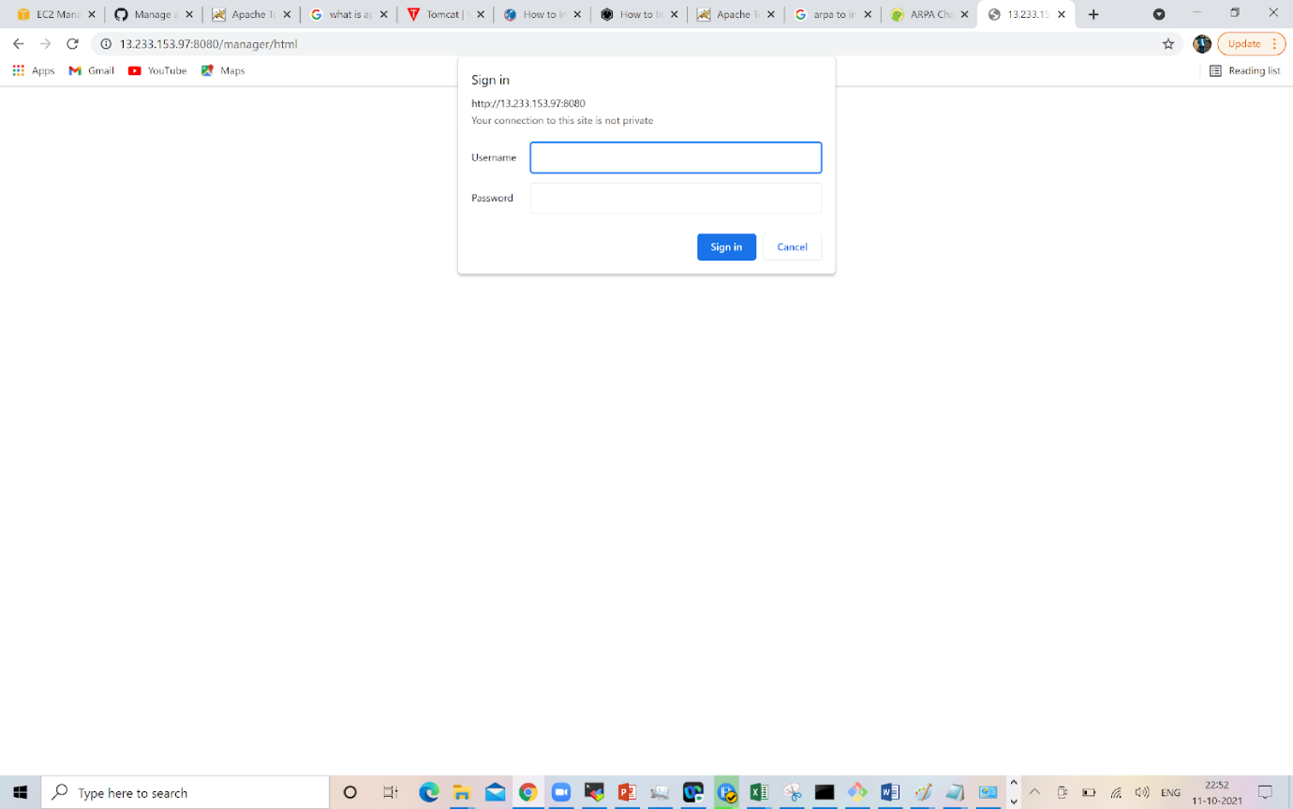

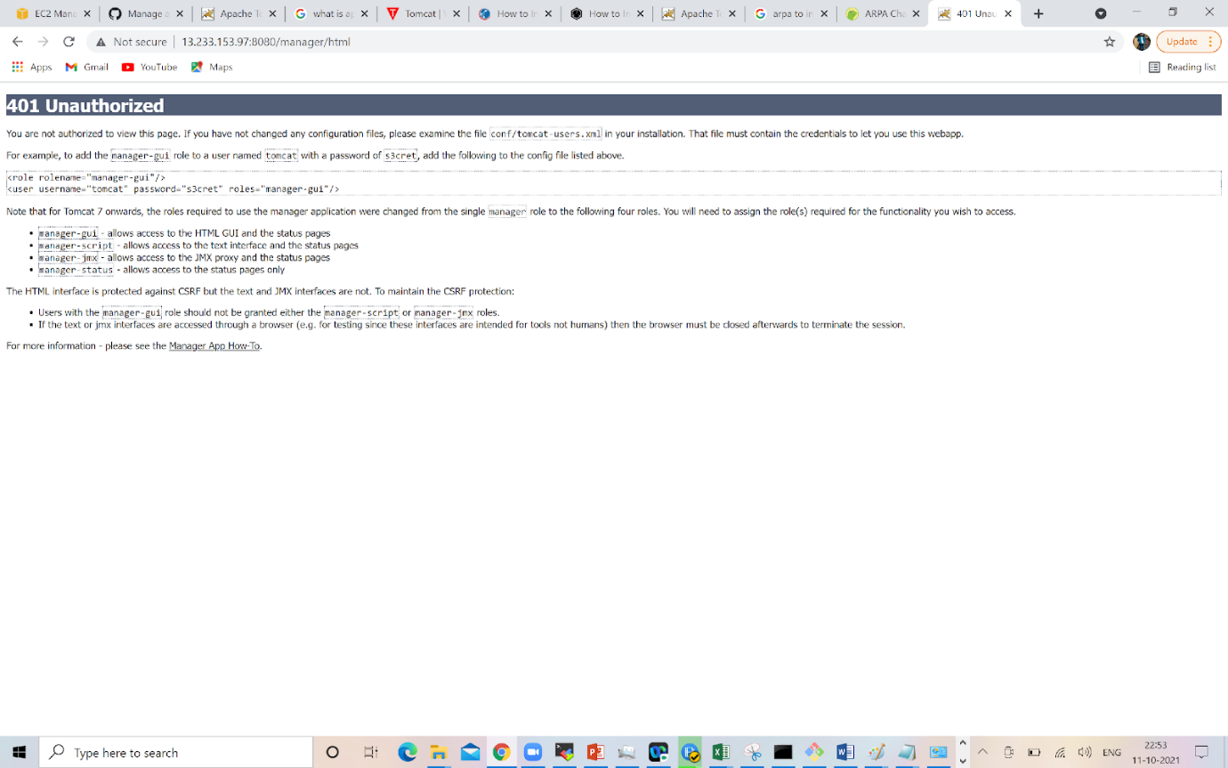

Now adding credentials for weblogin t tomcat, delete existing data from the tomcat-users.xml file and add the below lines

**:** sudo vi /opt/tomcat9/conf/tomcat-users.xml

Note: delete Existing data and and paste below script

<tomcat-users>

<role rolename="manager-gui"/>

<user username="admin" password="Admin" roles="manager-gui, manager-script, manager-admin, manager-status"/>

</tomcat-users>

Output of the screenshot should look as below

Save the file and come out of it.

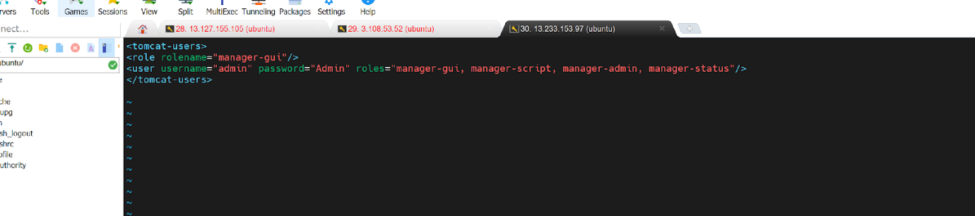

**Step11: Tomcat configuration is done deploy the war file under tomcat webapps directory**

**:**cd /opt/tomcat9/webapps/

: sudo wget https://get.jenkins.io/war-stable/2.303.2/jenkins.war